Brennan Schilling, MS4

Using Berkowitz Lab Macros and R Scripts to Analyze Mouse OCT Data

OCT Analysis Manual

**Downloading R: go to the website below and follow the prompts, download both 32- and 64-bit R (you will be using the 64-bit R)**

<https://cloud.r-project.org>

**Setting Up R:**

R may not have the necessary macros/files in its database upon installation to perform the required analyses.

The files you need for the Regulation macro in R are:

AnalyzefMRI

RNiftyReg

In order to check If you have these files: Open R and type in library(AnalyzefMRI), if an error appears it means you do not have these files. To download them: in R, go to Packages>>Install Packages>>Pick USA (OR)>> scroll until you find the packages you are missing.

If you notice any other errors saying you are missing other packages, follow the same path to download what you are missing.

To analyze the OCT images you first need to have Image J and the R software with the associated macros. The necessary Image J and R macros will be detailed below.

To Get Image J: go to this website: <https://imagej.nih.gov/ij/download.html>, and download the one specific to your operating system.

1. Open Image J, a small toolbar should appear at the top of your screen, as seen in the image below.
2. For each sup/inf folder you are sent, you will go to the images folder within the first folder, select all of the images (n=51), and drag them into Image J.
3. Once they have all popped up, go to your macros by this route seen below. 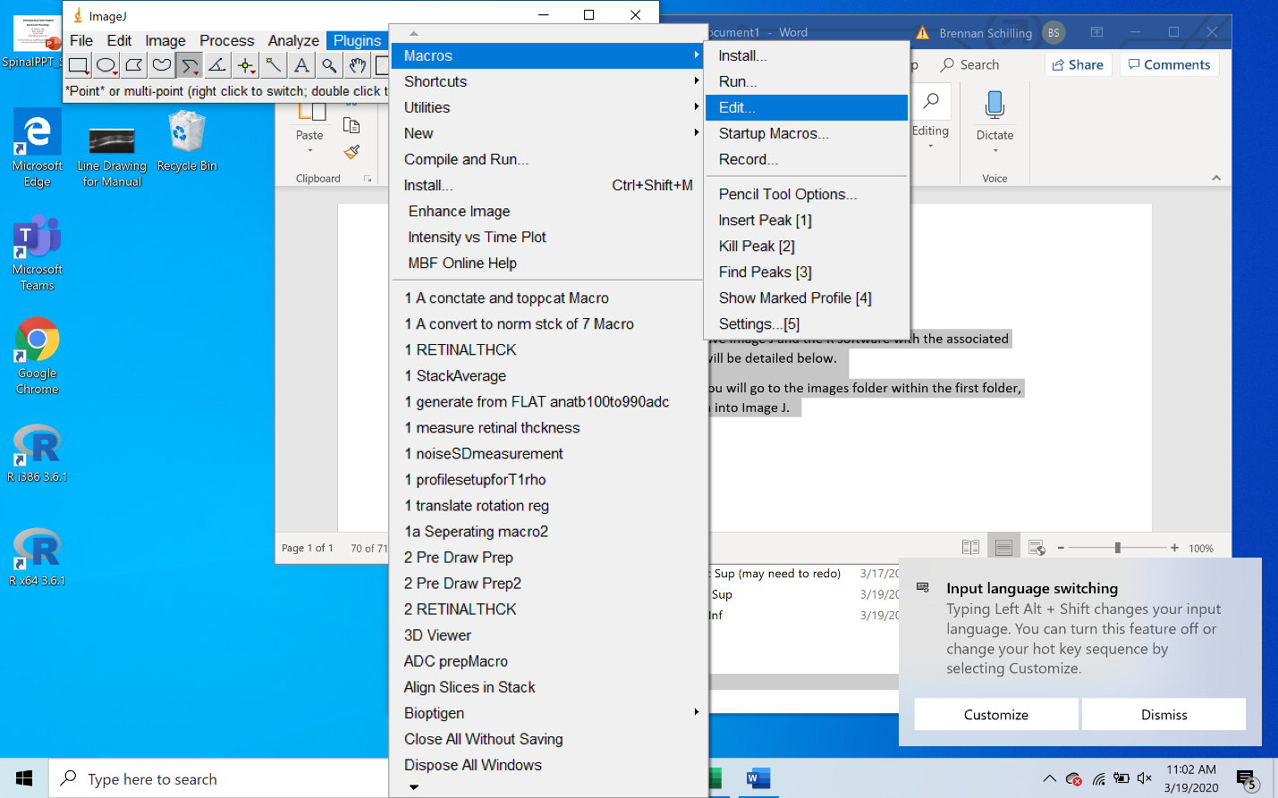
4. Pick the macro “Prep for Daves registration of OCT” (you may need to go back to MBF folder to get to macro folder)
   1. Where it says “Save=C:\\Users\\baberko\\...” you need to replace baberko with your username and save it.
      1. To find your username, go to any file in your documents, right click, and go to properties.
      2. In the window that pops up, you will see Location, with your username after Users as seen in the macro above
5. Run the Macro by either pressing Ctrl + R or clicking the Macro button on the macro and then clicking run.

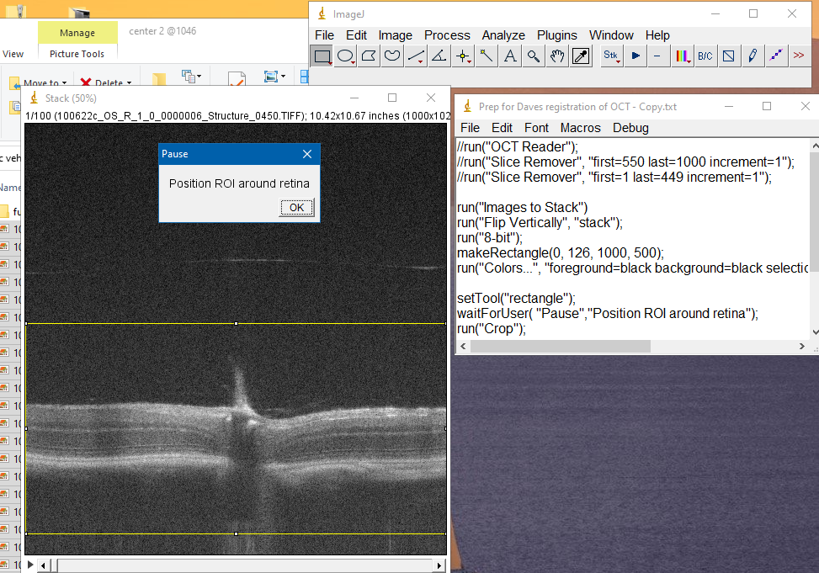

1. A yellow box will appear, make sure it includes the entire retina image, then click OK.
2. Two files will appear in where you designated in the Macro, those need to be in the same folder as all of your R files/R macros, so if they aren’t drag them into that folder.
3. After they are in your R folder, open up R.
4. In R, go to File🡪open script🡪REG_2019_100419
5. With that macro opened, go to Edit🡪Run all
6. Once the macro has finished (red vertical line), 4 images will appear in your R folder: forregstack_MEAN.hdr, forregstack_MEAN, forregStack_REGISTERED.HDR, forregStack_REGISTERED
   1. 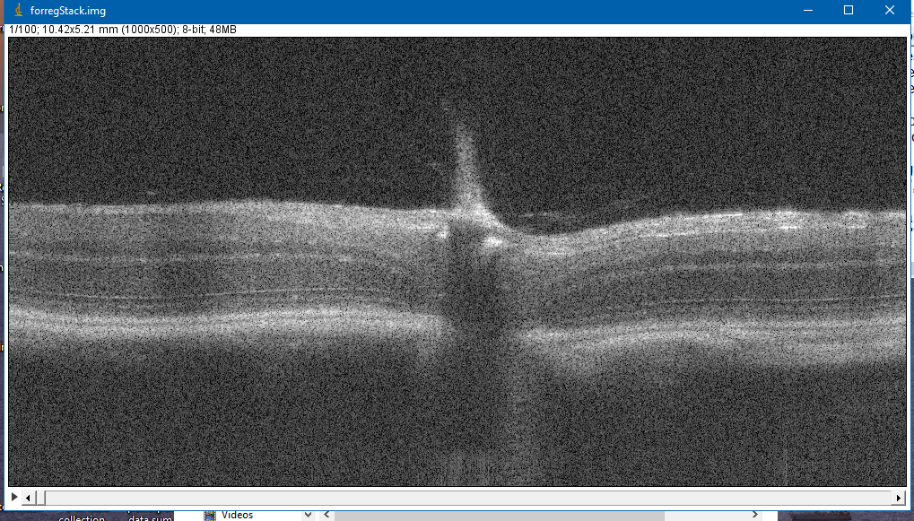Drag the forgestack_registered image into Image J and make sure the images are indeed visibly registered and that nothing weird has happened by dragging on the slider at the bottom of the image as seen below. If something weird happened then contact Dr. Berkowitz.
7. Now drag the forregStack_MEAN (disc image file) into image J, and an image should pop up like this:
8. Now, open up the macro: Prep for Daves OCT analysis program and run it just like we did for the previous Image J macro. Plugins, macro, edit, macro, control R.
   1. You will need to replace your username for baberko once again, but there will be three locations to do it, just search the macro for baberko and replace all three with your username, and save it.
9. Once you run this macro, you will be prompted to draw a series of lines on the image: 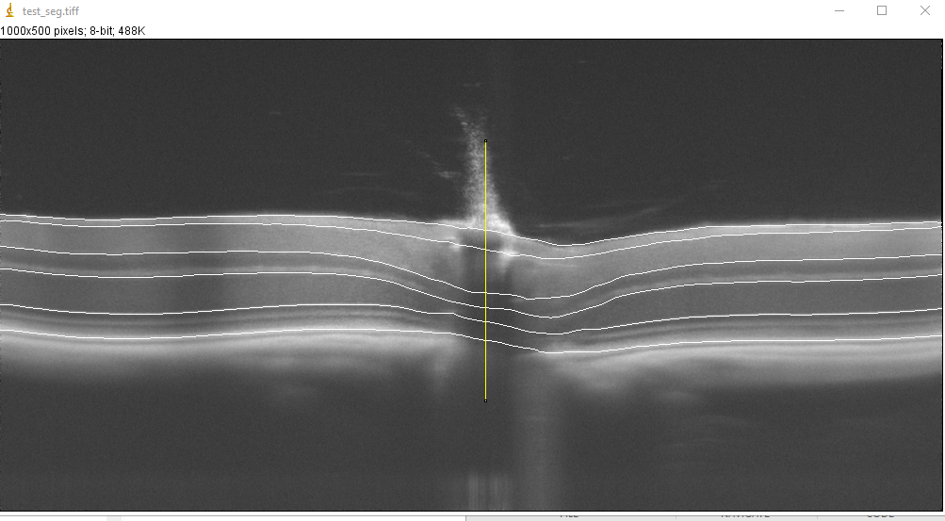
10. From bottom to top the lines are: RPE, ELM, ONL-OPL Border, INL-IPL Border, GCL-RNFL border, RNFL-Vitreous Border. Make sure to record your stop and start points for each line
    1. **For each line keep your X values at 1 for your start, 998 for your stop, and record your y-values for each line, as each analyst will use those values to standardize the drawing process.**
    2. RPE – Draw in the middle of the second bright band from the bottom
    3. ELM – Draw in the middle of the 4th bright line/band from the bottom
       1. This line can appear very faint and disappear from the image at times, try to keep the best fit and pattern.
    4. ONL-OPL Border – draw along the bottom of the bright band above the ELM
    5. INL-IPL Border – draw along the bottom of the bigger bright band above the ONL-OPL border
    6. GCL-RNFL Border – draw near the top of the image below the thin bright band at the top of the retina
       1. This is not always easy to see, but make sure to keep close to the very top of the retina.
    7. RNFL-Vitreous Border – draw on top of the retina
11. When you are drawing each line, double click to finish drawing, THEN press okay to move on to the next line.
12. Once all of these lines are drawn, you will be prompted to draw a straight line through the optic nerve.
    * 1. It is the area with a dark vertical band through the retina and the bright remnant shooting out from the top of the image
      2. Try to draw the line as in the center of the optic nerve as possible
         1. Make sure it is perfectly 90 degrees, which you can see in the image J toolbar, and record the X-value for that line.
13. Once the lines have all been drawn and you press Ok, three images will appear, Stack (disc image file) Stack.txt, and Stack.hdr
    1. If these files are not automatically in your R file, make sure to move them into your R folder
14. Open R again, and open either the center macro, open script, edit and run all, the same way as you opened your Registration macro.
15. Once the analysis is complete, a picture will appear in the R program that should look something like this: 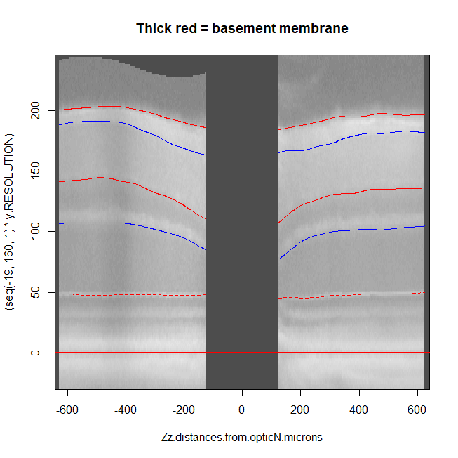

The lines should be a good fit for the areas that you drew lines for in Image J, if they do not fit correctly, redraw the lines with less spacing between points to try can get a better fit.

1. Once the fit looks good, go back into your R folder and you should see several new files:
   1. The files you need are the Stack_# and Stack_first-imageonly_thickness_details_i
   2. The first image only thickness file you will drag into the Excel Doc containing the “Dave reg output to columns” macro
      1. Once you drag it into the excel doc, go to the View tab in excel, then click Macros
         1. In the list of Macros, click the Dave Reg Output to columns and run it.
            1. It should organize the information into columns.
            2. Save this file into a folder labeled with the animal subject information.

In this folder, also put your Stack_# file and the first image only thickness.